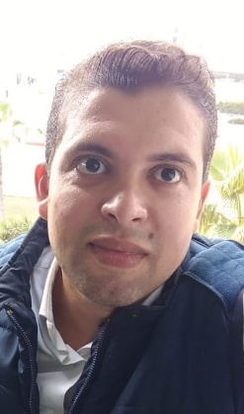
Curriculum Vitae (CV)

Muhammad Aziz Omar AbdEl Samad Kandil

Personal Information:
Academic Rank: Teaching Assistant
Department: Mechatonics Department
Specialization: Automatic control
Position: Teaching Assistant -
Email muahmmad.aziz@hti.edu.eg
Mobile/WhatsApp: +20/ 11110011110011

Education:
Degree | Discipline | Institution | Year
M.Sc. | Mechanical Design and Production Engineering | Shoubra Faculty of Engineering, Banha University, Egypt. | 2020
B.Sc. | Mechatronics Department | Higher Technological Institute 10_Ramadan University, Egypt. | 2006

Academic Experience:

Institution:
Rank: Teaching Assistant
Dates: 2020

Research interests:

- - Mechatronics and Robotics
- -Automatic Control

Publications:
- Kandel, M. A. O., Elsamanty, M., AbdRaboo, S. &. Hossamel-din, Y. H (2019) A Complete Identification Methodology for Identifying Parameters of Twin Rotor Multi Input Multi Output System (TRMS). International Journal of Science and Engineering Investigations (IJSEI), 8(91), 187-196. http://www.ijsei.com/papers/ijsei-89119-25.pdf

Teaching Experience:

Courses taught
- -Automatic Control.
- -Electronics.
- -Electric Circuits.
- -Electronic Lab.
- -Digital Circuits.

