http://www.mathalino.com/reviewer/engineering-mechanics/resultant-non-concurrent-force-system

The resultant of non-concurrent force system is defined according to magnitude, inclination, and position.
The magnitude of the resultant can be found as follows
The inclination from the horizontal is defined by
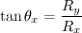
The position of the resultant can be determined according to the principle of moments.
Where,
F_{x} = component of forces in the x-direction
F_{y} = component of forces in the y-direction
R_{x} = component of thew resultant in x-direction
R_{y} = component of thew resultant in y-direction
R = magnitude of the resultant
θ_{x} = angle made by a force from the x-axis
M_{O} = moment of forces about any point O
d = moment arm
M_{R} = moment at a point due to resultant force
i_{x} = x-intercept of the resultant R
i_{y} = y-intercept of the resultant R

http://www.mathalino.com/reviewer/engineering-mechanics/problem-267-resultant-non-concurrent-force-system

Problem 267
The Howe roof truss shown in Fig. P-267 carries the given loads. The wind loads are perpendicular to the inclined members. Determine the magnitude of the resultant, its inclination with the horizontal, and where it intersects AB.
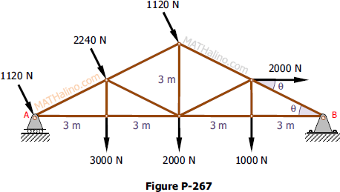
Solution 267
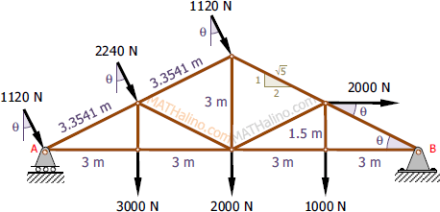
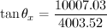
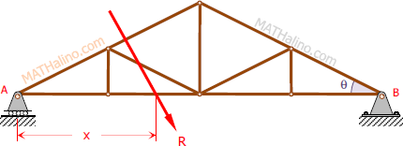
wrong equation
10007.03 x =48026.37
X =4.8 m to the right of A
wrong equation
Thus, R = 10 778.16 N downward to the right at θ_{x} = 68.2° passing 4.8 m to the right of A.

http://www.mathalino.com/reviewer/engineering-mechanics/problem-271-resultant-non-concurrent-force-system

Problem 271
The three forces in Fig. P-270 create a vertical resultant acting through point A. If T is known to be 361 lb, compute the values of F and P.
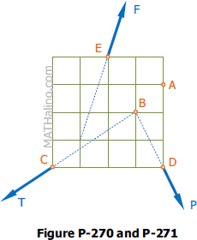
Solution 271
For vertical resultant, R_{x} = 0 and R_{y} = R
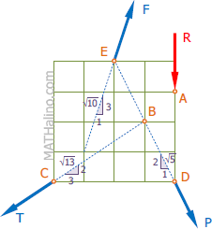
answer
answer

http://www.mathalino.com/reviewer/engineering-mechanics/problem-268-resultant-non-concurrent-force-system
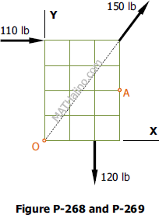
Problem 268
The resultant of four forces, of which three are shown in Fig. P-268, is a couple of 480 lb·ft clockwise in sense. If each square is 1 ft on a side, determine the fourth force completely.
Solution 268
Let F4 = the fourth force and for couple resultant, R is zero.
Thus,
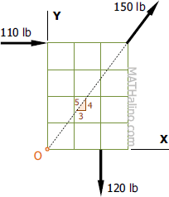
Assuming F₄ is above point O
d is positive, thus, the assumption is correct that F₄ is above point O.
Therefore, the fourth force is 200 lb acting horizontally to the left at 5.8 ft above point O. answer

