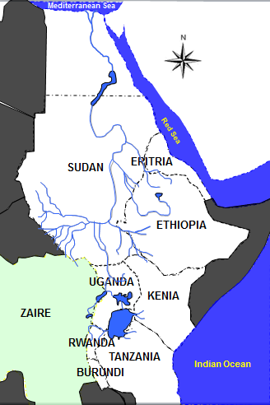
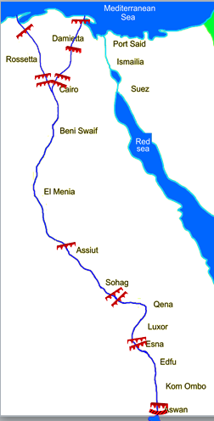
Figure 1
Figure 2
2
3
4
5
6
1
A
B
C

- (In figure 1) State the total annual freshwater volume arriving lake Nasser.
- (In figure 1) State the names of the three regions A,B,C and the percentage of flow arriving lake Nasser for each region.
- (In figure 2) state the name and construction date of each irrigation structure 1 to 6.
- (In figure 2) State the storage for each dam 5,6.

