http://www.mathalino.com/reviewer/engineering-mechanics/resultant-of-concurrent-force-system

Resultant of a force system is a force or a couple that will have the same effect to the body, both in translation and rotation, if all the forces are removed and replaced by the resultant.
The equation involving the resultant of force system are the following
- The x-component of the resultant is equal to the summation of forces in the x-direction.
- The y-component of the resultant is equal to the summation of forces in the y-direction.
- The z-component of the resultant is equal to the summation of forces in the z-direction.
Note that according to the type of force system, one or two or three of the equations above will be used in finding the resultant.

Resultant of Coplanar Concurrent Force System
The line of action of each force in coplanar concurrent force system are on the same plane. All of these forces meet at a common point, thus concurrent. In x-y plane, the resultant can be found by the following formulas:
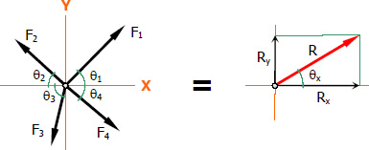
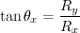

Resultant of Spatial Concurrent Force System
Spatial concurrent forces (forces in 3-dimensional space) meet at a common point but do not lie in a single plane. The resultant can be found as follows:
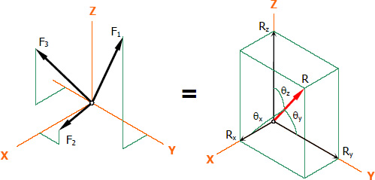
Direction Cosines
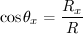
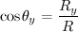
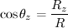

Vector Notation of the Resultant
Where

http://www.mathalino.com/reviewer/engineering-mechanics/012-resultant-two-velocity-vectors

Problem 012
Find the resultant vector of vectors A and B shown in Fig. P-012.
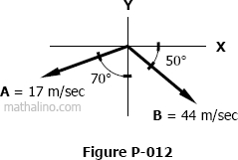

Solution 012: Component Method
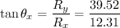
The resultant vector R = 41.39 m/sec downward to the right at θ_{x} = 72.70°.

Another Solution: Vector Method
(ok!)
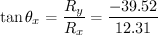
downward to the right (ok!)

Another Solution: Geometry Method
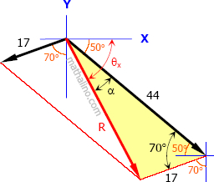
Cosine Law for the shaded triangle
(ok!)
By Sine Law
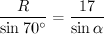
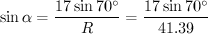
(ok!)

http://www.mathalino.com/reviewer/engineering-mechanics/013-resultant-three-forces-angles-greater-90-degree

Problem 013
Three vectors A, B, and C are shown in the figure below. Find one vector (magnitude and direction) that will have the same effect as the three vectors shown in Fig. P-013 below.
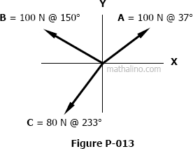

Solution 013
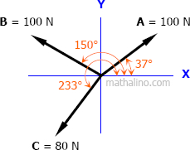
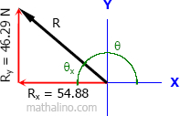
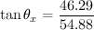
answer
http://www.mathalino.com/reviewer/engineering-mechanics/014-solving-force-given-resultant

Problem 014
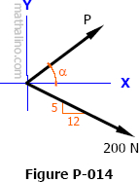
From Fig. P-014, P is directed at an angle α from x-axis and the 200 N force is acting at a slope of 5 vertical to 12 horizontal.
- Find P and α if the resultant is 500 N to the right along the x-axis.
- Find P and α if the resultant is 500 N upward to the right with a slope of 3 horizontal to 4 vertical.
- Find P and α if the resultant is zero.

Solution 014
Part a: The resultant is 500N to the right along the x-axis
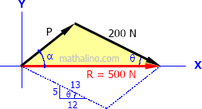
By Cosine law of the shaded triangle
answer
By Sine law
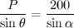
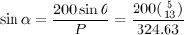
answer
Part b: The resultant is 500 N upward to the right with a slope of 3 horizontal to 4 vertical
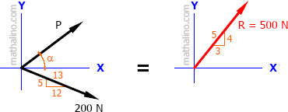
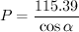
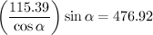
answer
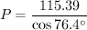
answer
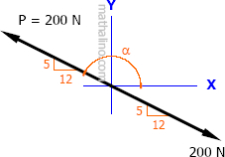
Part c: The resultant is zero
The resultant is zero if P and the 200 N force are equal in magnitude, oppositely directed, and collinear.
Thus, P = 200 N at α = 157.38° answer

http://www.mathalino.com/reviewer/engineering-mechanics/015-solving-force-and-its-angle-and-angle-two-forces-given-resultant

Problem 015
Forces F, P, and T are concurrent and acting in the direction as shown in Fig. P-015.
- Find the value of F and α if T = 450 N, P = 250 N, β = 30Â°, and the resultant is 300 N acting up along the y-axis.
- Find the value of F and α if T = 450 N, P = 250 N, β = 30Â° and the resultant is zero.
- Find the value of α and β if T = 450 N, P = 250 N, F = 350 N, and the resultant is zero.
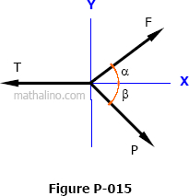

Solution 015
Part a: Unknown force and direction with non-zero resultant
and
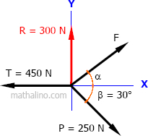
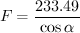
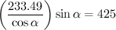
answer
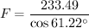
answer
Part b: Unknown force and direction with zero resultant
and
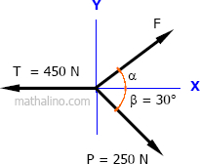
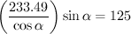
answer
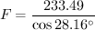
answer
Part c: Unknown direction of two forces with zero resultant
and
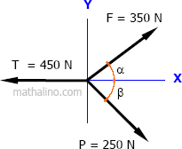
→ Equation (1)
→ Equation (2)
Equation (1) + Equation (2)
answer
From Equation (1)
answer

